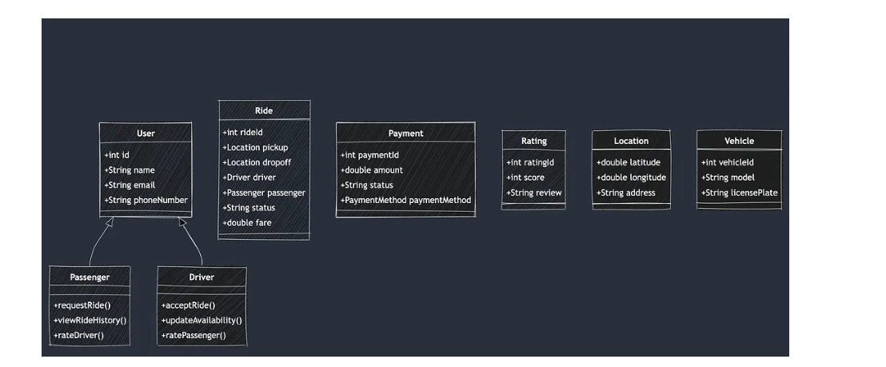

🧱 SOLID Principles in OOP (Ride-Sharing App Edition)
S – Single Responsibility Principle (SRP)
A class should have one and only one reason to change.
🔧 Example:
You shouldn’t have a Vehicle class that handles vehicle data and fare calculation.
✅ Instead:
class Vehicle {
private String driverName;
private Engine engine;
// only vehicle-related logic
}

class FareCalculator {
public double calculateFare(Vehicle vehicle) {
// fare logic
}
}
Now, if fare logic changes, you only touch FareCalculator, not Vehicle.

O – Open/Closed Principle (OCP)
Software entities should be open for extension, but closed for modification.
🔧 Example:
You want to support more vehicle types like ElectricCar, Bike, etc.
✅ Design using inheritance and polymorphism:
abstract class Vehicle {
abstract double calculateFare();
}

class Car extends Vehicle {
double calculateFare() { return 100; }
}

class ElectricCar extends Vehicle {
double calculateFare() { return 80; }
}
Now you can add new types without modifying the existing ones.

L – Liskov Substitution Principle (LSP)
Objects of a superclass should be replaceable with objects of subclasses without breaking the system.
🔧 Example: If Vehicle vehicle = new ElectricCar();
Then vehicle.calculateFare() should behave properly without knowing it's an ElectricCar.
❌ Bad: If ElectricCar overrides the method but throws UnsupportedOperationException, that breaks LSP.
✅ Good: All subclasses respect the contract of the base class.

I – Interface Segregation Principle (ISP)
Clients should not be forced to depend on interfaces they don’t use.
🔧 Example: Instead of:
interface Vehicle {
void drive();
void fly(); // not all vehicles fly!
}
✅ Split into smaller, focused interfaces:
interface Drivable {
void drive();
}

interface Flyable {
void fly();
}

class Car implements Drivable { ... }
class Drone implements Drivable, Flyable { ... }
This avoids unnecessary implementation in classes like Car.

Got it, Talha. That example is too basic. Let’s take a realistic ride-sharing system example—like something you'd actually design with 2 years of backend dev experience.
🚘 Interface Segregation Principle (ISP) – Ride Sharing App Example
❌ Bad Design (violates ISP):
interface Driver {
void acceptRide();
void cancelRide();
void completeRide();
void rechargeElectricBattery(); // Not all drivers have EVs
}
class PetrolCarDriver implements Driver {
public void acceptRide() { /*...*/ }
public void cancelRide() { /*...*/ }
public void completeRide() { /*...*/ }
public void rechargeElectricBattery() {
throw new UnsupportedOperationException("Not applicable");
}
}
✅ Good Design (follows ISP):
interface BasicDriver {
void acceptRide();
void cancelRide();
void completeRide();
}

interface ElectricVehicleDriver {
void rechargeElectricBattery();
}

class PetrolCarDriver implements BasicDriver { /*...*/ }

class EVDriver implements BasicDriver, ElectricVehicleDriver { /*...*/ }
💡 Benefits:
- Code is cleaner, testable, and extendable.
- No dummy/empty methods.
- You can inject interfaces in DI more precisely.

D – Dependency Inversion Principle (DIP)
High-level modules should not depend on low-level modules. Both should depend on abstractions.
🔧 Example:
Your TripService shouldn’t directly depend on CreditCardPayment or UPIPayment.
✅ Use an interface:
interface PaymentMethod {
void pay(double amount);
}

class CreditCardPayment implements PaymentMethod { ... }
class UPIPayment implements PaymentMethod { ... }

class TripService {
private PaymentMethod paymentMethod;

public TripService(PaymentMethod paymentMethod) {
this.paymentMethod = paymentMethod;
}

public void completeTrip() {
paymentMethod.pay(200);
}
}
This allows you to swap implementations easily, supports unit testing, and keeps your code loosely coupled.

🔚 TL;DR Interview Soundbite:
“In my ride-sharing system, I apply SOLID by separating fare logic from vehicles (SRP), designing vehicles to be extendable (OCP), ensuring all vehicle types work interchangeably (LSP), splitting behavior-based interfaces (ISP), and injecting payment methods using interfaces (DIP). This keeps the system modular, testable, and open to future growth.”

